1. My operating system is windows 11

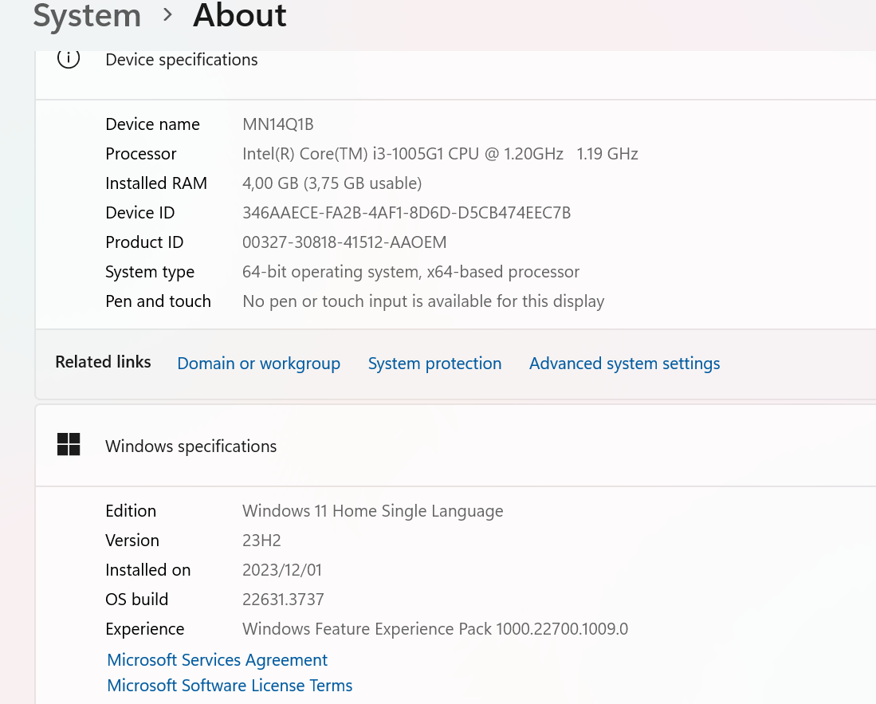

1. I downloaded and installed VS Code on my computer.

1. I have created a github account and one of my repositories is PLPAcademy.

1. I have installed python (refer to the second screenshot above).
2. .
3. I have downloaded and installed mysql, refer to the 2nd screenshot above.
4. .
5. I have installed necessary extensions inside vs code.

